sixteenth Sunday
after Pentecost
September 20, 2020

Messiah Lutheran Church ELCA
Deacon Kari Olson

Our Savior’s Lutheran Church ELCA
Pastor Erik Roth



PRELUDE Mark Ongalo

WELCOME Deacon Kari Olson, Pastor Erik Roth

GATHERING HYMN Great is Thy Faithfulness ELW# 733
Mark Ongalo, Carolyn Flaschberger

CONFESSION & FORGIVENESS
Blessed be the holy Trinity, ☩ one God,
who creates, redeems, and sustains us and all of creation. Amen.
Let us confess our sin in the presence of God and of one another.
Silence is kept for reflection.

Faithful God,
have mercy on us.
We confess that we are captive to sin and cannot free ourselves.
We turn from your loving embrace and go our own ways.
We pass judgment on one another before examining ourselves.
We place our own needs before those of our neighbors.
We keep your gift of salvation to ourselves.
Make us humble, cast away our transgressions,
and turn us again to life in you through Jesus Christ, our Savior and Lord. Amen.

God hears the cries of all who call out in need, and through his death and resurrection,
Christ has made us his own.
Hear the truth that God proclaims:
Your sins are forgiven in the name of ☩ Jesus Christ.
Led by the Holy Spirit, live in freedom and newness to do God’s work in the world. Amen.

GREETINGS The grace of our Lord Jesus Christ, the love of God, and the communion of the Holy Spirit be with you all. And also with you.

KYRIE ELW Pg. 203
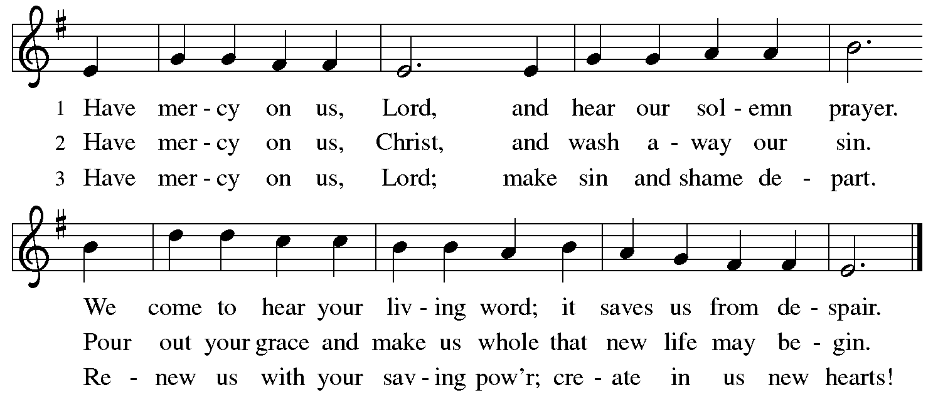

HYMN OF PRAISE ELW Pg. 204

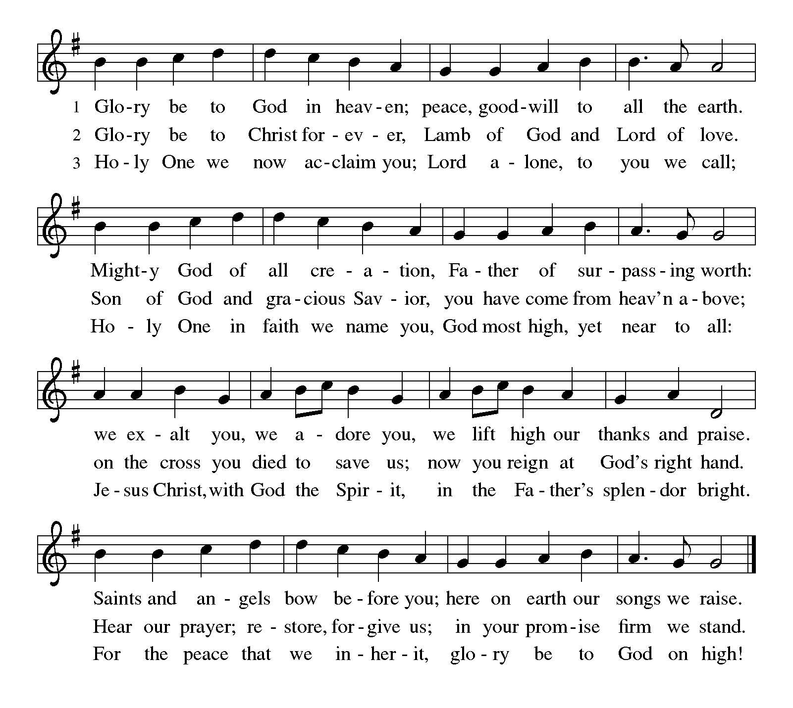

PRAYER OF THE DAY
Almighty and eternal God, you show perpetual lovingkindness to us your servants. Because we cannot rely on our own abilities, grant us your merciful judgment, and train us to embody the generosity of your Son, Jesus Christ, our Savior and Lord. Amen.

CHILDREN’S MESSAGE Deacon Kari Olson

FIRST READING: Jonah 3:10--4:11
¹⁰When God saw what [the people of Ninevah] did, how they turned from their evil ways, God changed his mind about the calamity that he had said he would bring upon them; and he did not do it.
^{4:1}But this was very displeasing to Jonah, and he became angry. ²He prayed to the Lord and said, “O Lord! Is not this what I said while I was still in my own country? That is why I fled to Tarshish at the beginning; for I knew that you are a gracious God and merciful, slow to anger, and abounding in steadfast love, and ready to relent from punishing. ³And now, O Lord, please take my life from me, for it is better for me to die than to live.” ⁴And the Lord said, “Is it right for you to be angry?” ⁵Then Jonah went out of the city and sat down east of the city, and made a booth for himself there. He sat under it in the shade, waiting to see what would become of the city.
⁶The Lord God appointed a bush, and made it come up over Jonah, to give shade over his head, to save him from his discomfort; so Jonah was very happy about the bush. ⁷But when dawn came up the next day, God appointed a worm that attacked the bush, so that it withered. ⁸When the sun rose, God prepared a sultry east wind, and the sun beat down on the head of Jonah so that he was faint and asked that he might die. He said, “It is better for me to die than to live.”
⁹But God said to Jonah, “Is it right for you to be angry about the bush?” And he said, “Yes, angry enough to die.” ¹⁰Then the Lord said, “You are concerned about the bush, for which you did not labor and which you did not grow; it came into being in a night and perished in a night. ¹¹And should I not be concerned about Nineveh, that great city, in which there are more than a hundred and twenty thousand persons who do not know their right hand from their left, and also many animals?”
Word of God. Word of Life. Thanks be to God.
*Reflections on the Scripture Reading, Deacon Kari Olson

PSALM 145:1-8
¹I will exalt you, my God and king,
and bless your name forever and ever.
²Every day will I bless you
and praise your name forever and ever.
³Great is the Lord and greatly to be praised!
There is no end to your greatness.
⁴One generation shall praise your works to another
and shall declare your power.
⁵I will speak of the glorious splendor of your majesty
and all your marvelous works.
⁶They shall tell of the might of your wondrous acts,
and I will recount your greatness.
⁷They shall publish the remembrance of your great goodness;
they shall sing joyfully of your righteousness.
⁸The Lord is gracious and full of compassion,
slow to anger and abounding in steadfast love.

SECOND READING: Philippians 1:21-30
²¹For to me, living is Christ and dying is gain. ²²If I am to live in the flesh, that means fruitful labor for me; and I do not know which I prefer. ²³I am hard pressed between the two: my desire is to depart and be with Christ, for that is far better; ²⁴but to remain in the flesh is more necessary for you. ²⁵Since I am convinced of this, I know that I will remain and continue with all of you for your progress and joy in faith, ²⁶so that I may share abundantly in your boasting in Christ Jesus when I come to you again.
²⁷Only, live your life in a manner worthy of the gospel of Christ, so that, whether I come and see you or am absent and hear about you, I will know that you are standing firm in one spirit, striving side by side with one mind for the faith of the gospel, ²⁸and are in no way intimidated by your opponents. For them this is evidence of their destruction, but of your salvation. And this is God’s doing. ²⁹For he has graciously granted you the privilege not only of believing in Christ, but of suffering for him as well—³⁰since you are having the same struggle that you saw I had and now hear that I still have.
Word of God. Word of Life. Thanks be to God.

HYMN BEFORE PRAYERS Lord, Listen to Your Children Praying ELW# 752

PRAYERS OF INTERCESSION After each petition, all reply, Hear our prayer.

GOSPEL ACCLAMATION ELW Pg. 205
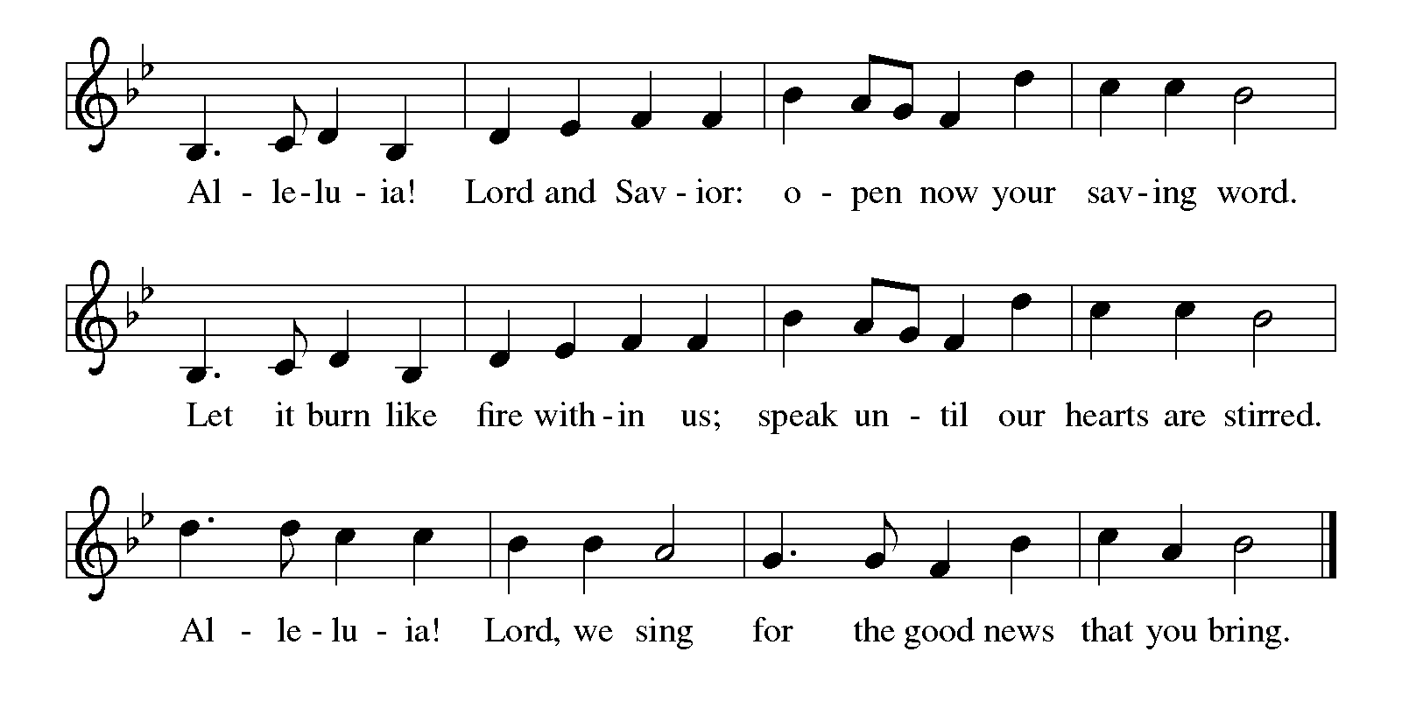

GOSPEL The Holy Gospel, according to Matthew 20:1-16, Glory to you, O Lord.

[Jesus said to the disciples:] ¹“The kingdom of heaven is like a landowner who went out early in the morning to hire laborers for his vineyard. ²After agreeing with the laborers for the usual daily wage, he sent them into his vineyard. ³When he went out about nine o’clock, he saw others standing idle in the marketplace; ⁴and he said to them, ‘You also go into the vineyard, and I will pay you whatever is right.’ So they went. ⁵When he went out again about noon and about three o’clock, he did the same. ⁶And about five o’clock he went out and found others standing around; and he said to them, ‘Why are you standing here idle all day?’ ⁷They said to him, ‘Because no one has hired us.’ He said to them, ‘You also go into the vineyard.’ ⁸When evening came, the owner of the vineyard said to his manager, ‘Call the laborers and give them their pay, beginning with the last and then going to the first.’ ⁹When those hired about five o’clock came, each of them received the usual daily wage. ¹⁰Now when the first came, they thought they would receive more; but each of them also received the usual daily wage. ¹¹And when they received it, they grumbled against the landowner, ¹²saying, ‘These last worked only one hour, and you have made them equal to us who have borne the burden of the day and the scorching heat.’ ¹³But he replied to one of them, ‘Friend, I am doing you no wrong; did you not agree with me for the usual daily wage? ¹⁴Take what belongs to you and go; I choose to give to this last the same as I give to you. ¹⁵Am I not allowed to do what I choose with what belongs to me? Or are you envious because I am generous?’ ¹⁶So the last will be first, and the first will be last.”
This is the Gospel of the Lord. Praise to you, O Christ.

*Reflections on the Scripture Reading, Pastor Erik Roth



HYMN OF THE DAY Canticle of the Turning ELW# 723

APOSTLES’ CREED

I believe in God, the Father almighty, creator of heaven and earth.
I believe in Jesus Christ, God’s only Son, our Lord,
who was conceived by the Holy Spirit,
born of the virgin Mary, suffered under Pontius Pilate,
was crucified, died, and was buried; he descended to the dead.*
On the third day he rose again; he ascended into heaven,
he is seated at the right hand of the Father,
and he will come to judge the living and the dead.
I believe in the Holy Spirit, the holy catholic church,
the communion of saints, the forgiveness of sins,
the resurrection of the body, and the life everlasting. Amen.

OFFERING HYMN Mark Ongalo, Carolyn Flaschberger

LORD’S PRAYER

Our Father, who art in heaven, hallowed be thy name,
thy kingdom come, thy will be done,
on earth as it is in heaven.
Give us this day our daily bread;
and forgive us our trespasses,
as we forgive those who trespass against us;
and lead us not into temptation, but deliver us from evil.
For thine is the kingdom,
and the power, and the glory,
forever and ever. Amen.

BLESSING Mothering God, Father, ☩ Son, and Holy Spirit, bless you and lead you into the way of truth and life. Amen.

SENDING HYMN Christ Be Our Light ELW# 715

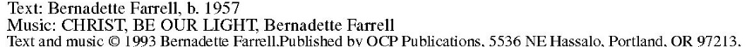

SENDING Go in peace. Serve the Lord. Thanks be to God.

Thank you for worshipping with us today.
Deacon Kari Olson, Pastor Erik Roth
Piano: Mark Ongalo
Cantor: Carolyn Flaschberger

From sundaysandseasons.com. Copyright © 2020 Augsburg Fortress. All rights reserved. Reprinted by permission under Augsburg Fortress Liturgies Annual License #SB124425. New Revised Standard Version Bible, Copyright © 1989, Division of Christian Education of the National Council of the Churches of Christ in the United States of America. Used by permission. All rights reserved.


Join us for the shared DRIVE-IN SERVICES this month. The next two weeks – Sept. 20 & Sept. 27th services will be held at Our Savior’s Lutheran Church in the parking lot starting at 10:30am.
*After the 9:30am recorded service airs on KRBT 1340AM

If you are in need of a Bible, Hymnal, or Christ in Our Home Devotional booklet please call the church office and we will gladly get them to you! 218-741-6207.
You may also call Pastor directly at 218-404-0007 for needs or prayer.
Deb Lekatz is the Prayer Chain contact person this month, you may call her at 218-290-2361 (cell), or 749-6247 (home phone) for any prayer needs you have.



